Arduino Busy waiting, no optimizations:

15.8mA Led Off

18.6mA Led On

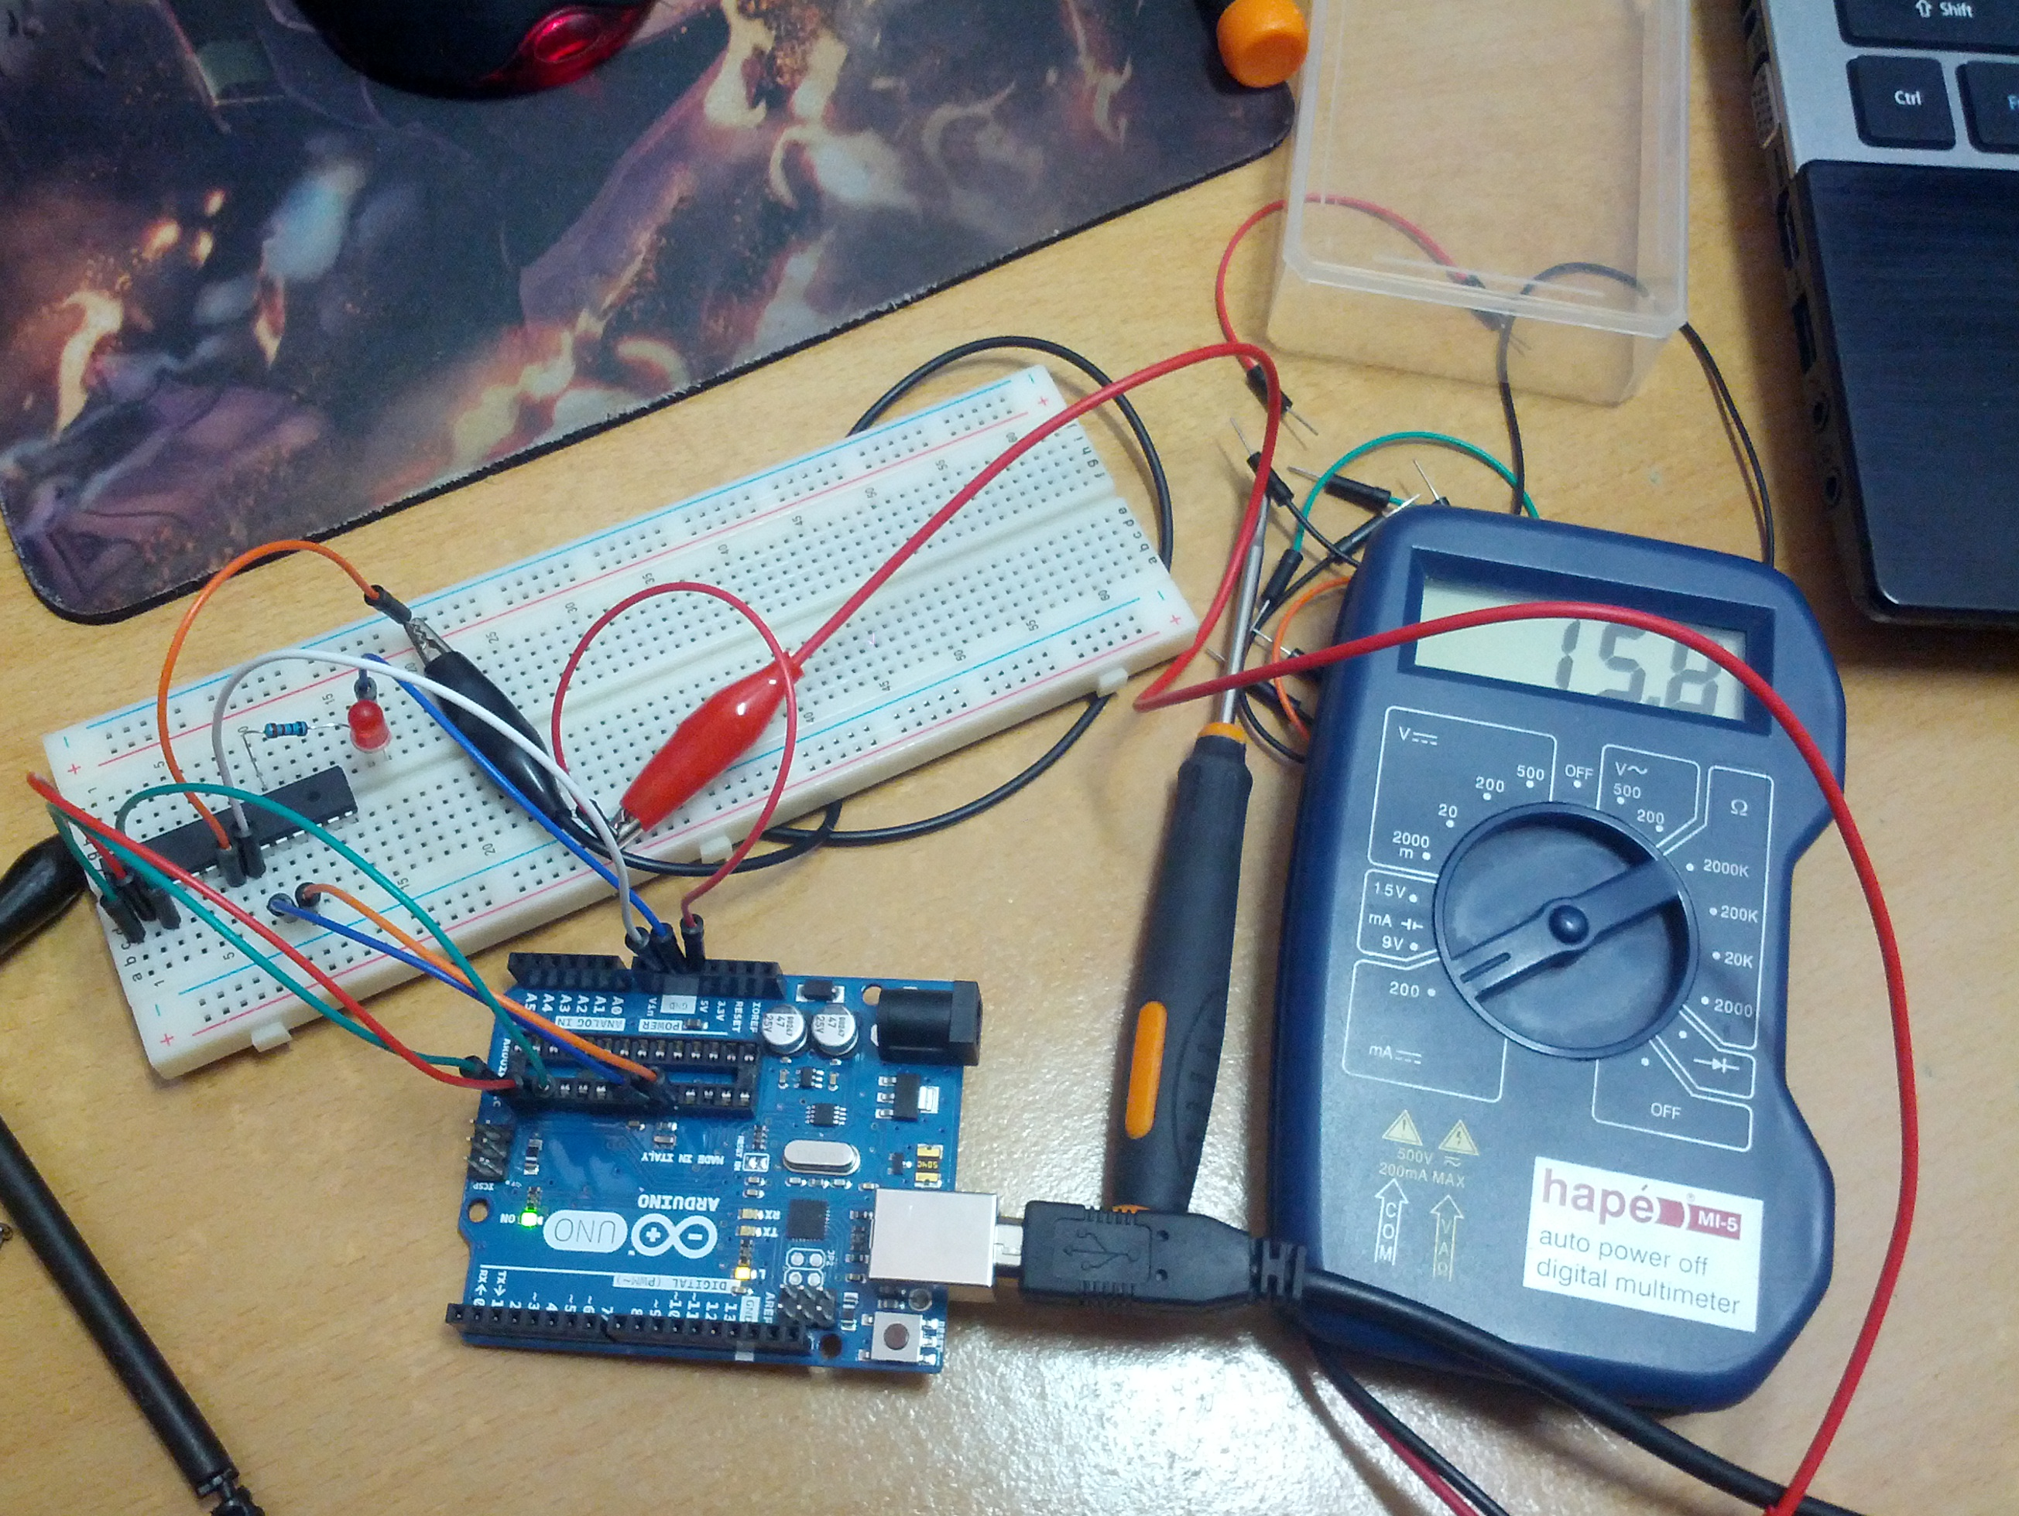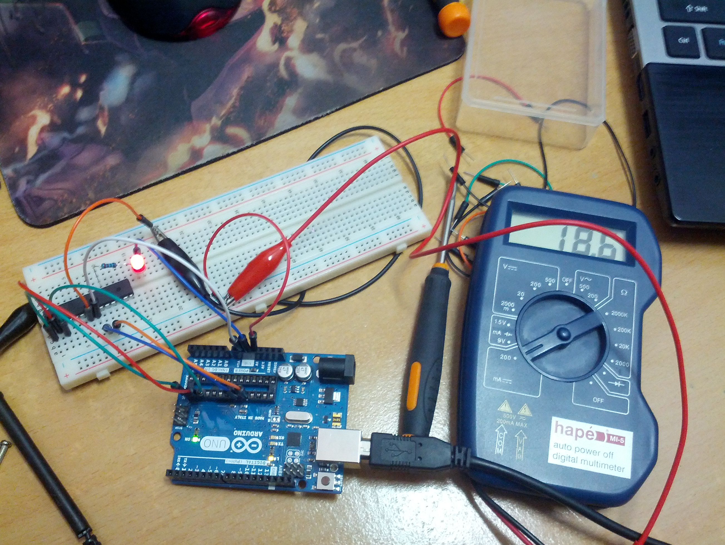

Arduino Busy waiting, turned off ADCSRA, ACSR, DIDR0, DIDR1, PRR

Led Off: 12.9mA

Led On: 16.2mA

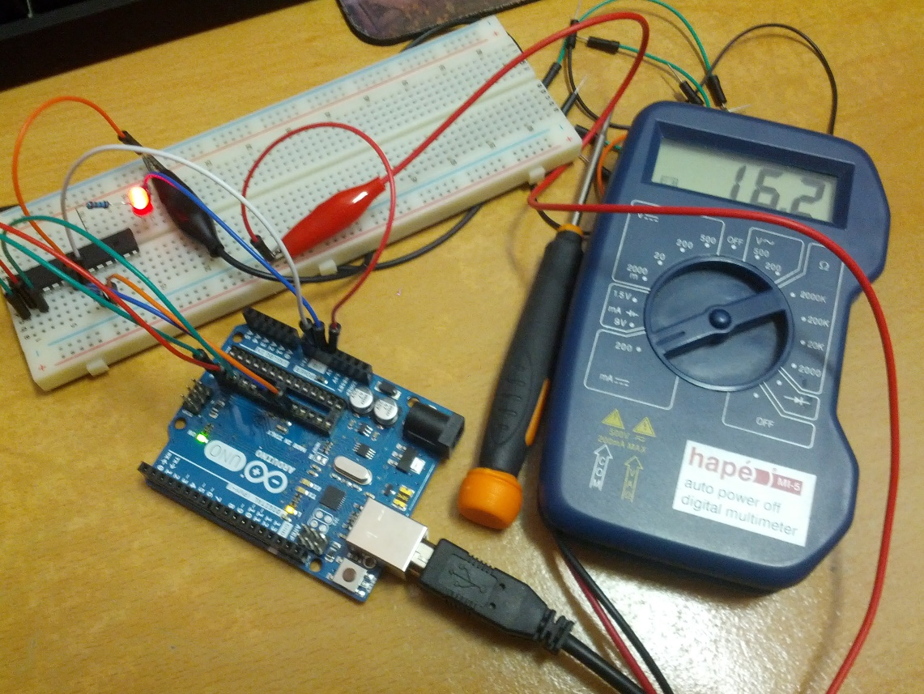

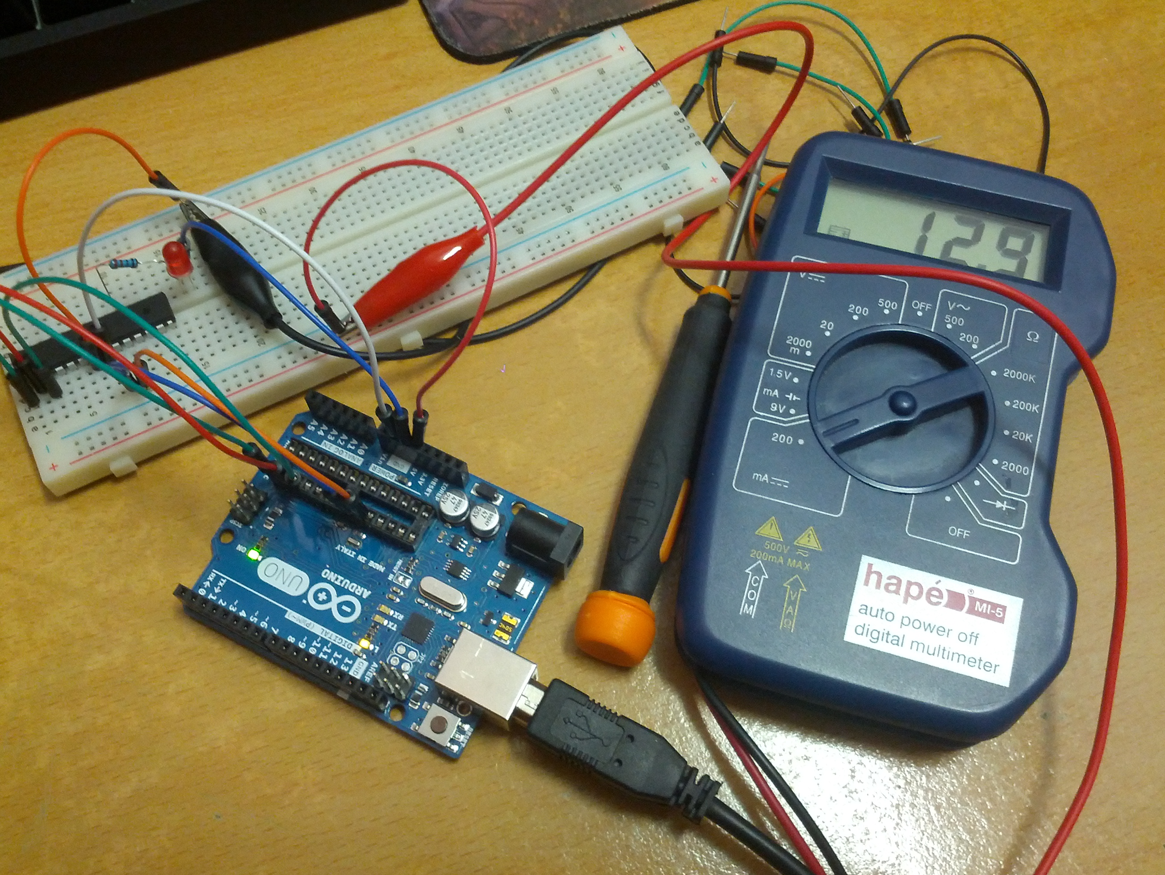

Cont. Step 9